**Contents**

#### Executive Summary

1.1 Strategic Location………………………………………………………………………………..……… 2

1.2 Company Ownership and Investment……………………………………………….………….……… 3

1.2.1 Investment Break-Down…………………..……………………...……………………….……… 4

1.2.2 E-2 Investor’s Profile ……………………………………………...……………………………… 6

#### Business and Service

2.1 Business Description …………………………………………………………….………………………7

2.2 Services ………………………………………………………………………....……………………… 7

2.2.1 Residential Restorations…..…………………………………………………………….…………8

2.2.2 Commercial Remodeling..…………………………………………………………………………8

2.2.3 Looking Ahead ……………………………………………………………………………………9

#### Clients

3.1 Customer Segmentation …...……………...…………………………………………………………...10

3.2 Customer Analysis ……………………………………………………………………………………...10

3.3 Prospective Key Clients …………………..……………………………………………………..……..12

#### Industry Analysis

4.1 Remodeling Market Size and Growth Trends …………………………………………………………13

4.2 Economic Factors ………………………………………………………………………………………13

4.3 Residential and Commercial Market Analysis …………………………………………………………15

#### Marketing Plan

5.1 Website and Online Presence Enhancement ……………………………………………………...…..16

5.2 Ongoing Social Media Engagement ……………………………………………….…………………...17

5.3 Ongoing Direct Interactions ……………………………………………………………………..…….18

5.4 Traditional Media Marketing………………………...……………………………………………..…..18

5.5 Referral Program……………………………………………………...………………………………..18

#### Key Management and Personnel

6.1 Organization Chart …………………………………………………………………………...……..…19

6.2 Team Personnel and Responsibilities …………………………………………………….…...……….20

#### Competitive Analysis

7.1 Competitors …………………………………………………………………………………………...21

7.2 Competitive Advantages ………………………….…………………………………………………...22

7.2.1 Founders’ Credentials ………………………………………………………………………22

7.2.2 Multi-County Presence …………………………….………………………………………..23

7.2.3 Established Relationships with Clients ……………..……………………………………….23

7.2.4 Partnership with Property Investor ………………………………………………..……….24

7.2.5 Strong Online Presence ………………………………………………….………………….24

7.2.6 Service to Commercial and Residential Clients ………………….………………………….25

#### Financial Plan

8.1 Revenue Drivers ……………………………………………………………………………...……..…25

8.2 Cost Drivers ………………………………………………………………………………………...…..26

8.3 Summary of Financial Projections…...…………………………………….………………………….. 26

8.4 5-Year Financial Forecast …………………………………………………………………...…………..27

# Executive Summary

Within the real estate realm, a general contractor remodeling business specializes in delivering comprehensive services for both residential and commercial properties. Unlike subcontracting companies that focus solely on specific services, such as plumbing or electrical work, a general contractor remodeling business adopts a holistic approach to remodeling projects. This approach involves the meticulous management and supervision of all aspects of a remodeling project, spanning from initial design and planning to the final stages of project completion. These projects often require specific expertise and licenses, such as in mechanical, electrical, and plumbing work. In such cases, general contractor remodeling businesses may enlist subcontractor services to complete these specific aspects of the project under commission.

Remodeling and renovating services is the exact area that CaPri Services of Florida, LLC (hereinafter referred to as “CaPri Services” or “the Company”) has strategically aligned its focus on to achieve its business objectives. For residential properties, CaPri Services aims to collaborate with both property development companies and individual clients who aspire to reimagine their interior and exterior living spaces — ranging from kitchen and bathroom renovations to landscaping and maintenance of the outdoors. In the commercial realm, CaPri Services targets partnerships with businesses aiming to develop or enhance retail spaces tailored to their needs, whether it involves optimizing office environments or crafting inviting atmospheres for eateries and shops. As CaPri Services looks ahead to Year 3, the Company envisions expanding its services portfolio to include construction projects that involve creating entirely new spaces, often from the ground up, to meet the unique needs of its clients.

## 1.1 Strategic Location

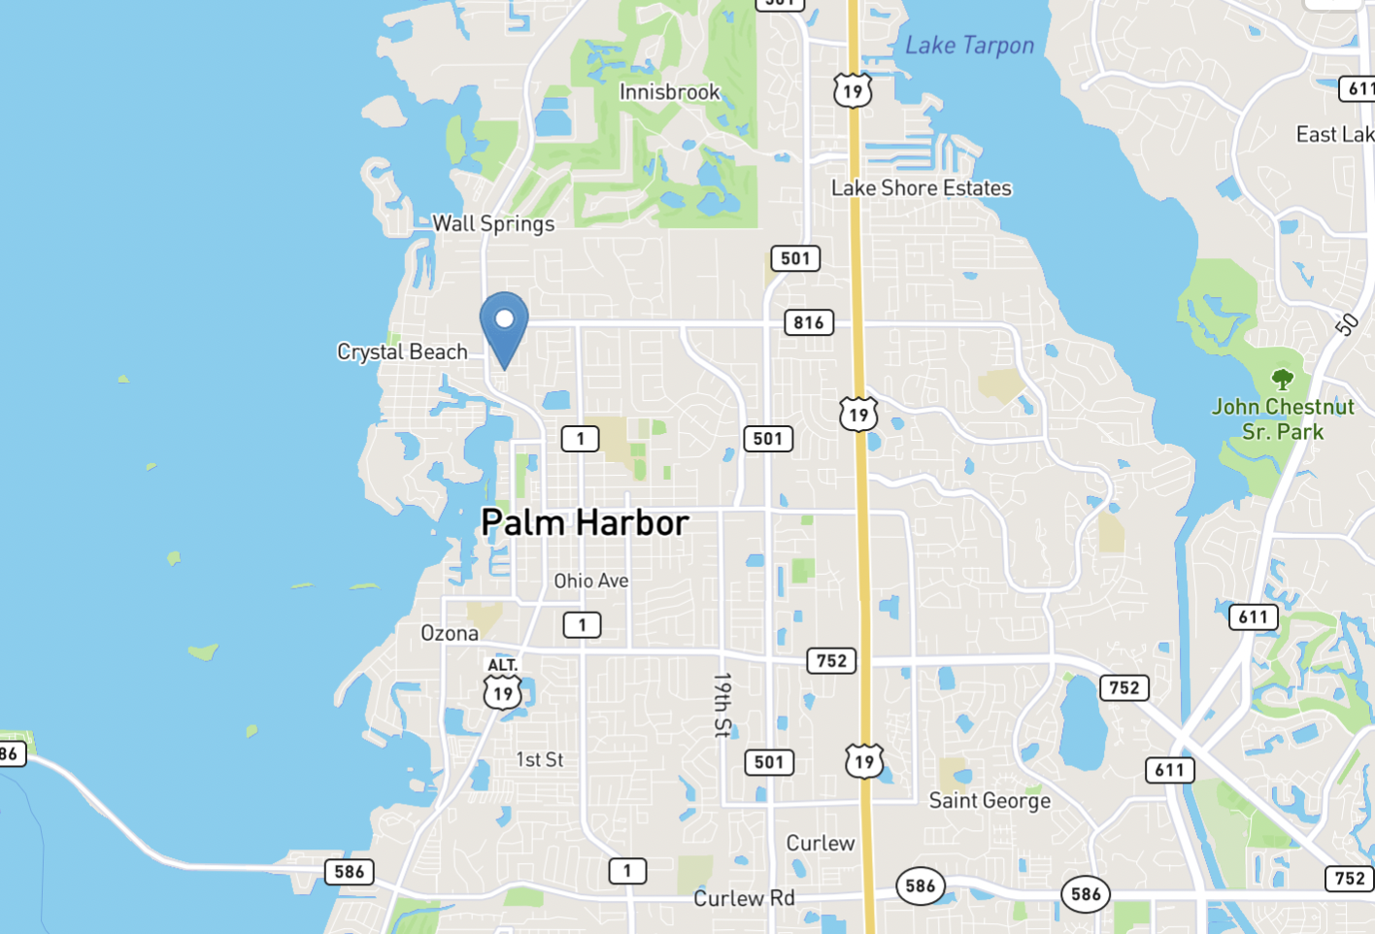

On September 1, 2023, CaPri Services took a significant step by finalizing a 5-year lease agreement with Flo-Five Holdings, LLC (the lessor) to secure a 1,698-square-foot office space at 2706 Alternate 19 North, Suite 506, Palm Harbor, Florida 34683 (also known as the “Key West Center”). This strategic location places CaPri Services at the heart of the Tampa Bay Area in South Florida, offering convenient access to the thriving community of over 60,000 residents in Palm Harbor. Among the 100-plus tenants in the vast retail center, CaPri Services gains the invaluable opportunity to network and draw potential business collaborations. Furthermore, the advantageous traffic flow along Alternate US-19 ensures heightened visibility and accessibility, providing a clear competitive advantage.

This primary space, Suite 506, will serve as a centralized hub for project planning, meetings, document storage, and seamless coordination with clients, subcontractors, and suppliers. While the core office operates within the Tampa Bay area, CaPri Services will also expand its presence by working in additional regions in South Florida, including Palm Beach and Broward County, where the Company established contact with prospective clients leading up to the start of operations of CaPri Services .

## 1.2 Company Ownership and Investment

CaPri Services was officially organized as an Limited Liability Company on August 31, 2023, with its inception credited to Mr. Alejandro Hugo Garcia Ilvento (“Mr. Ilvento”), an Argentinean national. Mr. Ilvento holds the majority ownership stake at 75% and is set to assume the role of President and Chief Executive Officer (CEO) providing the Company with visionary leadership, once his E-2 visa is approved. The remaining 25% ownership interest is held by Company investor Mr. Hugo Florido (“Mr Florido”), who will serve as Secretary and Chief Operations Officer (COO).

Mr. Ilvento has personally contributed $120,000 to CaPri Services and will be responsible for high-level decision making of all the Company’s operations. Additionally, Mr. Florido has invested $60,000, and will offer fundamental financial insight into the market, further bolstering the startup's financial foundation. This joint investment underscores their shared confidence in the Company's potential for success.

| **Personal Funds Invested** | |
| --- | --- |
| **Mr. Ilvento’s Personal Funds** | **$120,000** |
| **Mr. Florido’s Investment** | **$60,000** |
| **Total Investment** | **$180,000** |

### 1.2.1 INVESTMENT BREAKDOWN

The investment breakdown for CaPri Services intricately lays out the financial prerequisites essential for initiating the company’s operations. It's crucial to note that a portion of these expenditures has already been addressed, while the remainder is poised for procurement upon visa approval. This meticulous financial planning ensures a swift and seamless launch, minimizing any hindrances to providing top-notch remodeling solutions to our valued clients. As a result of meticulous planning, the investment was broken down into four primary sections: start-up costs; immediate investment upon approval; distribution of remaining funds; and finally, future financial obligations.

1. **Start-Up Costs**

The startup investment breakdown for CaPri Services outlines the initial financial needs to commence the Company’s operations. It is essential to highlight that these expenses have already been covered. This meticulous planning ensures a swift and efficient launch of our services, minimizing any delays in delivering exceptional remodeling solutions to clients.

Prior to visa approval, CaPri Services proactively secured an office space and covered initial incorporation expenses, as well as legal fees, totaling $17,050.

| Formation of Company Fees | $650.00 |
| --- | --- |
| Legal Fees | $11,000.00 |
| Security Deposit — Office Lease | $2,900.00 |
| Business Plan | $2,500.00 |
| Total | $17,050.00 |

1. **Immediate Investment Upon Visa Approval**

Following approval, the Company is fully prepared to immediately execute the remaining immediate investments for materials and a down-payment for transportation, amounting to an additional $29,560.34. Once these expenses are covered, CaPri Services will be equipped to begin operations promptly.

| Truck Down Payment | $5,000.00 |
| --- | --- |
| Equipment and Materials | $27,414.39 |
| Liability Insurance | $2,140.95 |
| Total | $29,560.34 |

1. **Distribution of Remaining Funds**

To ensure a seamless start of operations, it is important to consider fundamental costs of operations to cover the first few months of operations while the Company establishes a strong presence in the market. In order to accomplish a profitable start, CaPri Services will distribute the remaining of it’s initial funds in the following manner:

| Salaries and Wages | $90,000.00 | Cover salaries for essential staff, for the first two months of operations. |
| --- | --- | --- |
| Marketing and Advertising | $5,000.00 | Support various marketing campaigns. |
| Inventory and Materials | $30,000.00 | Procure construction materials, fixtures, and supplies in initial projects without delays. |
| Working Capital | $25,000.00 | This financial buffer is designed to manage day-to-day expenses, including utility bills, rent, and miscellaneous costs. |
| Emergency Fund | $20,000.00 | Safeguard against unforeseen costs or setbacks that may arise during the early phases of operations. |
| Total | $170,000.00 |  |

By allocating the remaining $170,000 investment in this manner, CaPri Services can ensure a strong start to its operations, cover essential expenses, and have the flexibility to handle unexpected challenges, all while working toward achieving its projected first-year revenue of $695,000. These strategic allocations of funds reflect CaPri Services' commitment to delivering excellence in its field, building a strong foundation for growth, and adapting to the dynamic business landscape.

1. **Future Financial Obligations**

While the initial investment will be sufficient to cover expenses to start operations, it is also important to note that CaPri Services initial investments demonstrate a long-term financial commitment to be secured through the company’s success. Below follows a total breakdown of the company’s future financial obligations to be covered monthly:

| Office Lease (60 months) | $205,752.48. |
| --- | --- |
| Truck (72 months) | $110,472.70 |
| Total | $293,172.70 |

### 

### 

### 

### 

### 1.2.2 E-2 TREATY INVESTOR PROFILE

Mr. Ilvento is the driving force behind CaPri Services, equipped with a Bachelor of Business Administration from Mackenzie University and nearly three decades of entrepreneurial and managerial expertise. His illustrious career encompasses ownership and management of five thriving businesses in the domains of hospitality, tourism, and event management. A standout highlight in his journey is his remarkable success with Rapid College Turismo Ltda ( “College Turismo”), a prestigious student tourism agency based in Brazil, primarily serving Argentina. Over 23 years, Mr. Ilvento diligently expanded College Turismo's reach by engaging new clients, ensuring their satisfaction, negotiating with service providers, and managing financial operations. His relentless dedication led to College Turismo being sought after by over 1,000 schools, facilitating travel for more than 3,000 passengers per season. Notably, in 2006, College Turismo's exceptional growth and international recognition culminated into the attainment of International Air Transport Association (IATA) Certification, which certifies the company’s financial stability, professional staff, business relationships , among others. This accomplishment serves as a staple proof of Mr. Ilvento’s entrepreneurial success and experience, which positions him as an ideal leader of CaPri Services. With expertise in client acquisition, staff management, and financial stewardship, Mr. Ilvento's leadership will be instrumental in driving CaPri Services to unparalleled success.

Mr. Ilvento will assume a vital Executive role at CaPri Services, where his responsibilities will encompass the comprehensive oversight of the Company's operations and finances. In his capacity as the Chief Executive Officer and majority shareholder, Mr. Ilvento will ensure the effective functioning of all business aspects, oversee project management, contract acquisition, quality workmanship assurance, financial management, client relations, and marketing strategies. His commitment extends to expanding job opportunities and generating income substantially beyond personal living expenses, given his role as a shareholder receiving 75% dividends from the company's annual profits, in addition to a competitive annual salary of $52,000.

# 2. Business and Services

## 2.1 Business Description

CaPri Services will take immense pride in its expansive array of services, meticulously designed to cater to the diverse needs of clients spanning both the commercial and residential markets. With a dedicated team of highly skilled professionals and access to premium materials, CaPri Services can seamlessly address the unique requirements of clients in these sectors. Whether it's revitalizing a commercial workspace or enhancing a residential property, CaPri Services will be committed to excellence in every project it undertakes, which will undoubtedly make it the trusted choice for top-quality remodeling and renovation solutions.

What sets CaPri Services apart is the Company’s focus on specialized services and meticulous customer service, personally overseen by CEO, Mr. Ilvento, who brings extensive entrepreneurial experience and an outstanding record of client acquisition. Additionally, Chief Operations Officer (COO) Hugo Florido, with over three decades of experience as a property investor in the real estate market, adds a unique dimension to the Company's operations. With an annual commitment exceeding $300,000 towards property renovations, Florido provides invaluable strategic insight, enriching CaPri Services' ability to deliver exceptional results in the industry.

## 2.2 Services

CaPri Services plans to serve the Florida markets with concentration in the South Florida and Tampa areas, offering a diverse range of renovation and remodeling services to meet the evolving needs of their clients. The following outlines some examples of the residential and commercial services the Company intends to provide:

### 2.2.1 RESIDENTIAL RESTORATION AND RENOVATION

* **Kitchen Remodeling:** includes design consultations, layout optimization, premium cabinet and countertop materials, flooring options, and lighting solutions. CaPri Services will manage all aspects, from demolition to installation.
* **Bathroom Renovations:** includes space assessments, tile selection, fixture upgrades, plumbing modifications, and storage solutions. CaPri Services will assist in tile selection, fixture upgrades, plumbing adjustments, and storage solutions.
* **Whole Home Renovation:** covers layout modifications, electrical and plumbing updates, flooring, custom millwork, wall finishes, and paint selections. CaPri Services ensures every detail aligns with the desired aesthetic and functionality.
* **Exterior Upgrades and Maintenance:** encompasses roofing evaluation, landscaping, exterior painting, pressure cleaning, and property maintenance for harmonious living. CaPri Services will ensure cohesive transformations that improve aesthetics and functionality while maintaining communal areas for a harmonious living experience.

### 2.2.2 COMMERCIAL REMODELING

* **Exterior Upgrades:** These services will encompass facade improvements, roofing repairs, and landscaping enhancements to the exterior of commercial buildings. CaPri Services will evaluate and address structural issues, ensuring the safety and longevity of your property. CaPri Service will focus on both aesthetics and functionality, we transform the external appearance of commercial buildings, creating a lasting impression.
* **Tenant Improvements:** CaPri Services will customize commercial spaces to meet tenant needs, enhancing overall satisfaction. The company’s prospective employees and subcontractors will specialize in partition installations, electrical and plumbing work, and interior finishes. This expertise will ensure that every aspect of the space aligns with tenant requirements, optimizing functionality and comfort. Additionally, the Company will also provide maintenance services for shared areas within commercial centers, fostering a positive environment for all tenants and visitors.
* **Restaurant Remodeling:** CaPri Services will also specialize in comprehensive restaurant remodeling services, designed to elevate the dining experience and drive business growth. Our expert team will work with restaurant owners to reimagine interior layouts, create inviting atmospheres, and ensure compliance with safety and health regulations. From ergonomic seating arrangements to innovative kitchen designs, the Company will cover every aspect of restaurant interiors.
* **Retail Spaces and Studios:** CaPri Services will offer versatile solutions for retail spaces, including studios. For retail spaces, the Company will focus on optimizing product displays, traffic flow, and interior aesthetics to captivate customers. Services for this style of environment will include meticulous design to fit the client’s vision, precise selection of materials, and flawless execution of required operations such as demolition, flooring and painting. The Company’s commitment to detail and craftsmanship ensures that retail and studio spaces not only look impressive but also function seamlessly to support business objectives.
* **Office Buildout:** CaPri Services specializes in office transformations by understanding the clients’ needs, redesigning layouts for efficiency, assisting in the voice of right flooring, and providing custom cabinet solutions. The Company’s expert painting services and tile installations enhance the space, while fixtures and lighting are installed to create the desired atmosphere.
* **Commercial Repairs:** CaPri Services handles a range of commercial property repairs, from roofing and facade improvements to interior fixes like drywall and ceiling repairs. The Company hires subcontractor experts in plumbing, electrical, and HVAC repairs, ensuring the property remains safe and comfortable.

### 2.2.3 LOOKING AHEAD

By Year 3, CaPri Services envisions expanding its offerings to include construction services, which would involve the creation and construction of new spaces, often from the ground up. As the Company ventures into construction services, the creation of more job opportunities is anticipated as additional skilled professionals will be required. This strategic expansion is also expected to boost the company's revenue, solidifying its prominent position in both the construction and remodeling industries. The Company's planned construction services include:

* **New Home Construction:** CaPri Services aims to undertake ground-up new home construction, covering architectural design, foundation work, and finishes with a focus on quality and innovation.
* **Commercial Building Construction:** CaPri Services plans to build structures intended for business or commercial purposes, including office buildings, retail spaces, and restaurants.

# 3. Clients

## 3.1 Customer Segmentation

CaPri Services strategically balances its client portfolio, with a significant focus on commercial clients — who contribute the majority of revenue — while maintaining a diverse client base that includes property management companies, general contractors, designers, and residential clients.

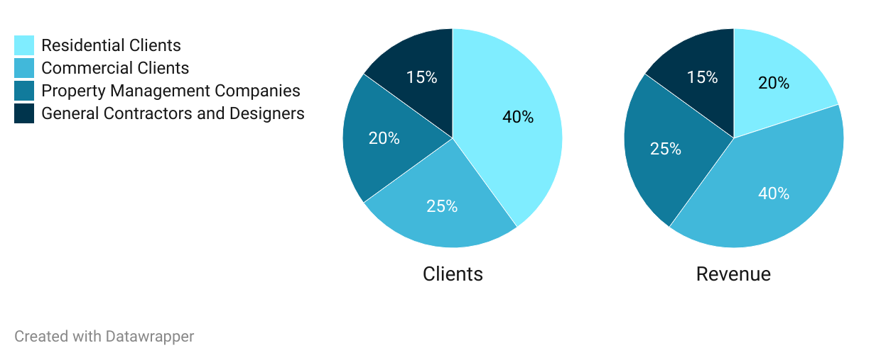

## 

## 3.2 Customer Analysis

CaPri Services' strategic focus on Pinellas, Hillsborough, Palm Beach, Broward, and Miami-Dade counties in South Florida is informed by their status as central hubs in East and West South Florida, marked by robust population growth and economic vitality. These counties encompass a diverse mix of potential customers, including single-family homes, apartments, and commercial establishments. CaPri Services aims to comprehensively grasp the demographics within this dynamic landscape, enabling us to customize remodeling and construction services to suit the diverse requirements of homeowners and businesses. This approach not only ensures a robust market presence but also unlocks promising avenues for growth. The demographics of CaPri Services focus areas are as follows:

|  | **Pinellas County** | **Hillsborough County** | **Palm Beach County** | **Broward County** | **Miami-Dade County** |
| --- | --- | --- | --- | --- | --- |
| **Residents** | 959,107 | 1,459,762 | 1,492,191 | 1,944,375 | 2,710,000,000 |
| **Residential Units** | 517,775 | 617,955 | 713,808 | 864,468 | 1,084,304 |
| **Total # of Commercial Establishments** | 60,006 | 80,033 | 103,332 | 129,830 | 184,476 |

### 

### 

### NUMBER OF ESTABLISHMENTS FOR RETAIL, FOOD AND ENTERTAINMENT INDUSTRIES BY COUNTY

*The area of the circles in the map is proportional to statistics according to the above data*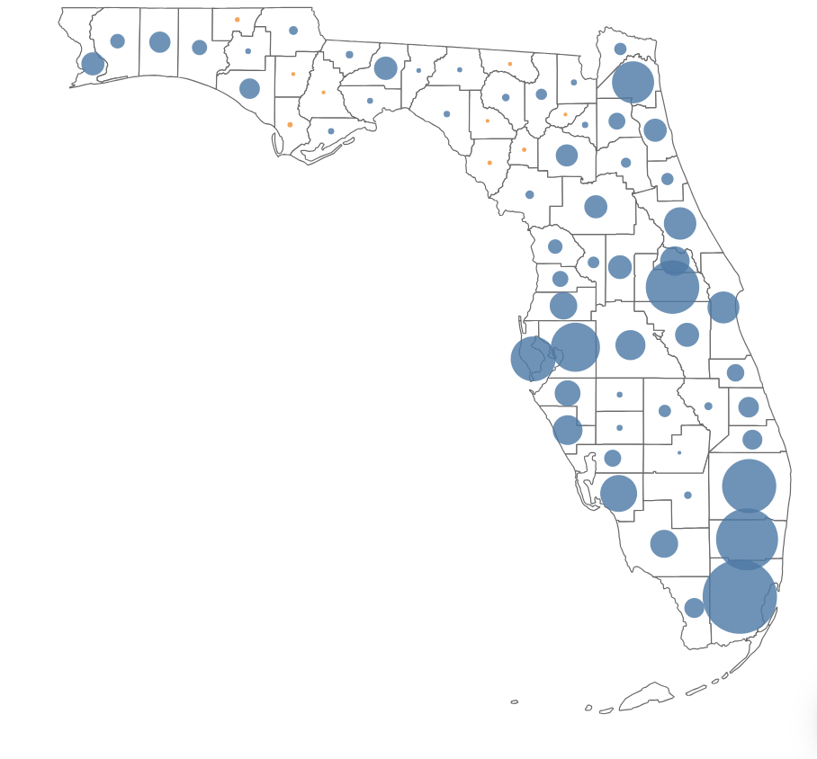

Miami-Dade, Palm Beach, Broward, Pinellas, and Hillsborough Counties are hubs of commercial growth within the vibrant state of Florida. These counties are key players in growing commercial sectors like retail, food, and entertainment. Recognizing that such markets inherently bring a heightened demand for transformative commercial remodeling, CaPri Services strategically sets its sights on these thriving counties. By aligning its focus with the heartbeat of growth, CaPri Services anticipates an exceptional avenue for expanding its business, fostering partnerships, and contributing its expertise to the evolution of these commercial landscapes.

The Company’s insights from the demographic data paint a vivid picture of Florida's dynamic housing landscape, guiding strategies to cater to both residential and commercial clients. The substantial number of occupied housing units, coupled with varying average household sizes and income distribution, highlights the diverse clientele the company aims to serve. By leveraging these statistics, CaPri Services can be strategically positioned to provide services that resonate with the unique needs of homeowners, property investors, and commercial businesses.

## 3.3 Prospective Key clients

As CaPri Services prepares to embark on its journey, Mr. Ilvento has taken proactive steps to establish crucial connections with potential clients who are eager to utilize the company's services across the vibrant regions of South Florida and the Tampa Bay area. Below, we introduce key clients and professional contacts who are poised to become integral to CaPri Services' success.

* **Carmela Coffee Company, LLC:** Carmela Coffee Company, a casual-dining coffee bar, presents a substantial opportunity for CaPri Services LLC. With ten locations across Broward and Palm Beach Counties and plans for further expansion in South Florida, Mr. Ilvento has engaged in discussions with Carmela's owner, Rafael Baretta. Their potential project revolves around remodeling Carmela's upcoming shop in West Palm Beach, spanning over 1,000 square feet. Upon Mr. Ilvento’s visa approval, this project will establish CaPri Services LLC as a trusted name in commercial remodeling.
* **Oxford Estates Association:** Oxford Estates, a well-regarded property development entity in Boca Raton, holds the potential to become a cornerstone of CaPri Services' portfolio. This Homeowners’ Association comprises 70 units, including 69 residential homes and a clubhouse. Situated strategically in West Boca Raton, Mr. Ilvento has initiated contact with John Monteleone, Oxford Estates Association treasurer. Their discussions encompass future community development and maintenance at Oxford Estates, extending to construction and remodeling services to individual residential clients in the area.
* **Parkview Villas Condominium Association, Inc:** Parkview Villas, a reputable property currently in Lake Worth, Florida, with an annual budget of approximately $100,000, seeks a dependable company for association maintenance projects. Mr. Ilvento has been in discussions with John Klingel, the association's secretary, exploring the possibility of CaPri Services becoming Parkview Villas' primary provider for maintenance projects, commencing in early 2024.
* **Pentagen Homes, LLC:** Pentagen Homes, a renowned contractor serving South Florida, is proactively exploring collaboration opportunities for residential and commercial development projects in 2024 and 2025. Mr. Ilvento has initiated discussions with Rafael Ramon, the General Manager of Pentagen Homes. Their conversations encompass a potential partnership spanning a diverse range of projects, each expected to exceed $250,000 in value. Once finalized, this prospective collaboration promises to expand CaPri Services' market presence and substantially enhance profitability.
* **Florido Enterprises Management Company:** CaPri Services has entered into a strategic partnership with Florido Enterprises, a reputable entity with a portfolio of over $75 million in commercial and residential properties. This partnership ensures a continuous revenue stream through repairs, renovations, and tenant improvements, expanding CaPri Services' reach and customer base.

# 4. Industry Analysis

## 4.1 Remodeling Market Size and Growth Trends

The remodeling industry in Florida is a thriving sector with considerable market size and promising growth trends. The state's diverse housing stock, including a mix of older homes and newer properties, provides a substantial market for remodeling services. The demand for remodeling has been bolstered by population growth, economic prosperity, and a resilient housing market. Over the past decade, Florida has experienced a steady increase in remodeling projects, driven by homeowners' desires to upgrade their properties, adapt to changing lifestyles, and enhance energy efficiency. Market data indicates a compound annual growth rate (CAGR) of approximately 5% in the remodeling sector, with this growth expected to continue in the coming years.

## 4.2 Economic Factors Florida's robust economy plays a pivotal role in driving the remodeling industry's growth. The state consistently experiences population growth, and as of 2022, a Census report confirmed that Florida is the nation's fastest-growing state, with a population increase of nearly 2% between 2021 and 2022.

**Florida Population Growth Over Time**

## 

*Source: US Census Bureau*

Moreover, the state's unemployment rate, currently standing at 2.9%, is the lowest it has been since 2006. This favorable economic climate is further reinforced by rising median household incomes, which have reached nearly $60,000, marking the highest level in the past three decades. These factors significantly contribute to increased consumer spending on home improvement projects. Furthermore, Florida's inviting climate attracts snowbirds, bolstering the state's tourism industry and fostering a favorable business environment that supports remodeling businesses. This economic resilience has also attracted new businesses to the area, resulting in a heightened demand for commercial remodeling services.

## 

## 4.3 Residential and Commercial Market Analysis

Florida's remodeling market is robust and versatile, driven by the substantial number of older homes requiring updates and renovations. According to a Census report, nearly 70% of Florida's homes were built before 2000, creating a consistent demand for modernization, including kitchen and bathroom renovations, home additions, energy-efficient upgrades, and hurricane-resistant improvements. Homeowners seek to enhance property value, energy efficiency, and adapt to evolving lifestyles.

The commercial remodeling sector in Florida is also flourishing due to a thriving business environment. The state attracts companies from diverse industries, resulting in increased demand for office, restaurant, retail, and hospitality sector renovations. Florida consistently ranks among the top states for business relocations and expansions, generating opportunities in sectors like technology and tourism.

In summary, Florida's remodeling markets offer diverse and sustained opportunities for CaPri Services. Older homes and a growing business landscape ensure consistent demand for remodeling services, making CaPri Services well-positioned to thrive in this dynamic market.

# 5. Marketing Plan

## 5.1 Website and Online Presence Enhancement

To bolster its online presence, CaPri Services is actively developing its website. The website, available at [https://www.capriservicesfl.com](https://capriservicesfl.com), will serve as a central hub for clients to access up-to-date information about the Company’s remodeling and renovation services and contact details. CaPri Services is committed to ensuring the website's user-friendliness, mobile compatibility, and security.

The website was professionally crafted on the GoDaddy platform, a renowned domain registrar trusted by over 20 million entrepreneurs worldwide to host their sites. Along with website design, the platform provides a variety of essential tools for digital marketing, including SEO, email marketing, social media management, and reputation management.

CaPri Services will allocate a portion of its budget to digital marketing initiatives aimed at driving traffic and improving online visibility. Their advertising campaigns will not only direct visitors to the website but also build brand awareness by displaying the company's logo and ad across the Google Display Network and other relevant websites, reaching potential clients interested in their services. Effective SEO and digital marketing campaigns are pivotal to their growth and development, elevating their search engine rankings, attracting more visitors, and subsequently, clients. CaPri Services is also actively leveraging the MyFloridaMarketplace platform to expand its reach. They plan to advertise their services on this platform, tapping into a broad audience of potential clients in Florida.

Furthermore, CaPri Services will actively promote the website through keyword marketing campaigns, concentrating on key terms like "remodeler" and "renovation contractor." These efforts align with Google trends data, which indicates sustained interest in renovation services in Florida, particularly in South Florida, where CaPri Services has established a presence and made valuable business connections. For example, according to Google trends, as demonstrated in the graph, “renovation” has been showing occasional fluctuations but remained high over the past twelve months in Florida. This trend is expected to continue.

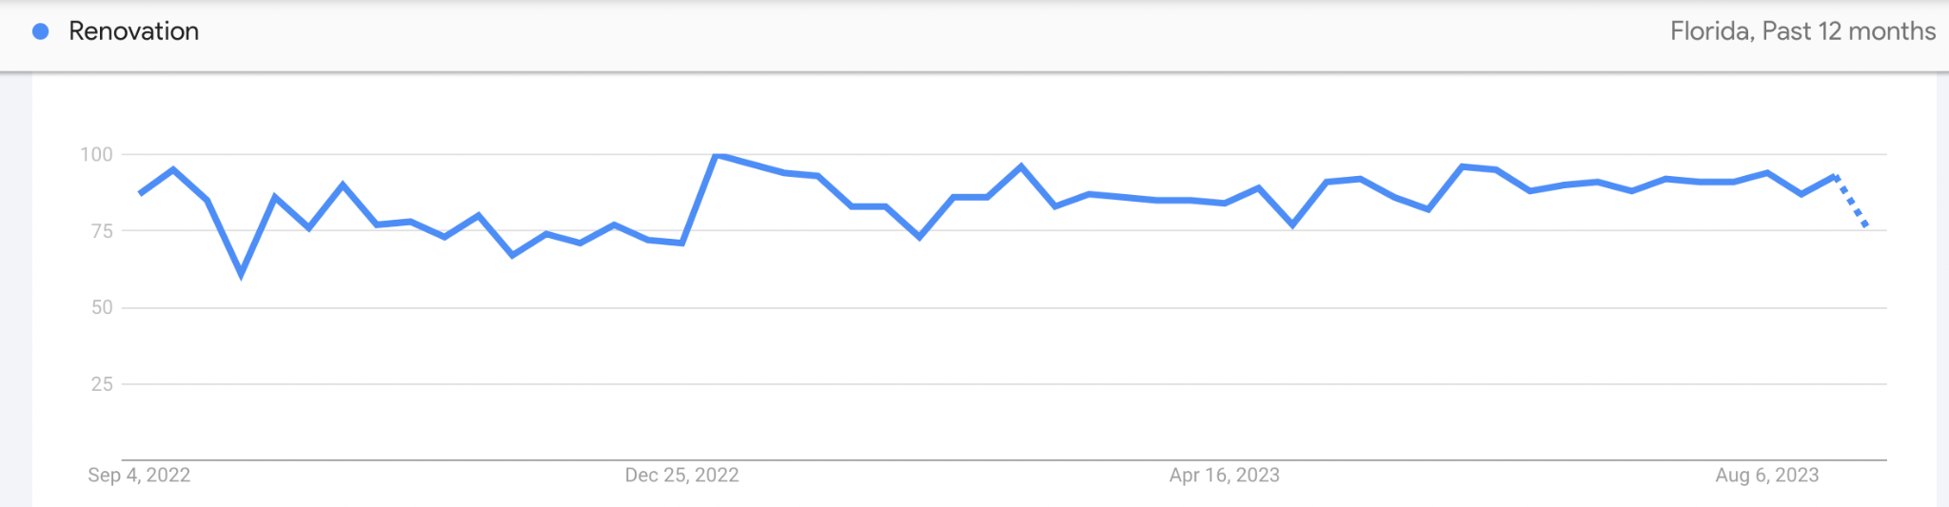

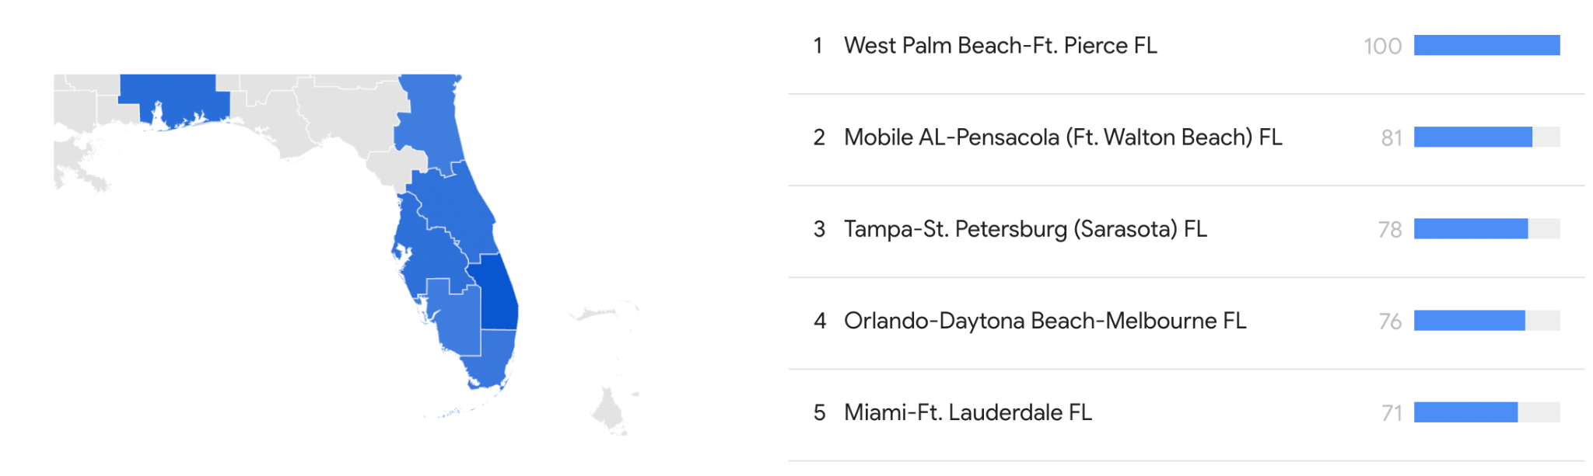

## 5.2 Ongoing Social Media Engagement

Understanding the pivotal role of social media in today's business landscape, CaPri Services has established profiles on key platforms such as Facebook, Instagram, and LinkedIn. Committed to dynamic engagement, the company uses these platforms to showcase project visuals, thus giving prospective clients an intimate view of the quality of work and the brand ethos. CaPri Services also plans to take advantage of technology enhancements and offer customers virtual walkthroughs, 3D modeling, and advanced project management software that can provide them with a better understanding of the project and its progress.

Communication is also streamlined with a dedicated email channel, contact@capriservicesfl.com, to foster straightforward interaction between the team and clients. To further amplify its reach, CaPri Services is in the planning stages of initiating an email marketing campaign targeting property owners interested in remodeling or renovation services. Email lists will be sourced from firms specializing in customer data collection via web cookies.

## 5.3 Ongoing Direct Interaction

Engaging with the local community in person remains a valuable strategy for CaPri Services to establish a robust presence. The Company is committed to actively participating in local community events, trade shows, and home expos, which allows them to directly interact with individuals seeking remodeling services. Through these personal interactions, CaPri Services aims to build rapport and trust, ensuring that potential clients recognize the company's dedication to their needs. Moreover, CaPri Services strategically chose a central location at the Key West Center in Palm Harbor due to its hosting of networking events and its status as a retail center with over 100 tenants. CaPri Services plans to utilize these invaluable opportunities to network and foster potential business collaborations among the numerous tenants in the retail center.

## 5.4 Traditional Media Marketing

To ensure a diversified approach to client acquisition, CaPri Services will utilize traditional media channels alongside its digital initiatives. Features in established local print and online publications, as well as industry news sources, are part of this multifaceted strategy.

CaPri Services plans to distribute their flyers and business cards within the commercial epicenter of Key West Center and within residential community clubhouses. These marketing materials will also be disseminated via social media platforms and featured prominently on the company's website to maximize reach.

## 5.5 Referral Program

As part of its growth strategy, CaPri Services will benefit from a referral incentive which will award discounted rates to client’s who recommend the Company’s services to others. This initiative aligns with the company's broader goal of building lasting client relationships and encouraging word-of-mouth referrals. Mr. Ilvento's established professional connections will play a significant role in broadening the company's reach. The goal is to nurture long-term partnerships that yield consistent business, referrals, and fresh avenues for opportunity. At the core of the referral program is the incentivization of client referrals through special offers and discounts, effectively turning satisfied customers into active brand advocates.

# 6. Key Management and Personnel

## 6.1 Organizational Chart

The organizational chart below outlines the projected structure of CaPri Services by Year 5.

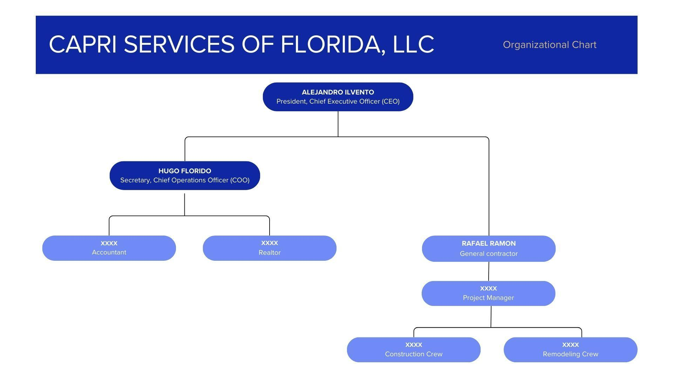

CaPri Services has laid out a robust roadmap for its future operations. Upon approval of the E-2 visa in Year 1, the Company aims to build a proficient team that will include an Accountant, Realtor, General Contractor, Project Manager, and at least two remodeling workers. Alongside this core team, CaPri Services will collaborate with reliable subcontractors for specialized tasks such as electrical, plumbing, and mechanical work. The Company has already been in contact with KiloVolt Electric, a certified electrical service provider, about subcontracting the company for upcoming endeavors and will continue securing additional subcontracting partnerships to diversify its offerings. Core remodeling services like framing, painting, and tile and cabinet installation will be managed in-house. Mr. Ilvento also worked to recruit a general contractor and signed an independent contractor agreement with Rafael Ramon, a licensed and experienced General Contractor, to oversee the entire spectrum of operations and subcontractor management.

By Year 3, CaPri Services plans to broaden its scope to include new building construction, which will require the addition of at least two construction workers to the team. In Years 4 and 5, the company aims to sustain its current organizational structure while also expanding its workforce, adding at least one new full-time employee each year to support its growing services.

## 6.2 Team Personnel

| **Position** | **Position Description** | **Expected Education Level** | **Responsibilities** |
| --- | --- | --- | --- |
| **Chief Executive Officer**  **(Alejandro Ilvento)**  **Salary: $52,000** | Drives growth, ensures financial stability, and maintains client satisfaction. | Bachelor's degree in business administration, management, or a related field | Lead and manage staff, oversee project management, contract acquisition, quality workmanship assurance, financial management, client relations, and marketing strategies |
| **Chief Operations Officer**  **(Hugo Florido)** | Strategically manages key areas, supervises accountant and realtor. | Bachelor’s or Masters’ degree in a related field | Collaborate with an accountant, oversee realtors, contribute to strategic plans, and assist resource allocation. |
| **Accountant** | Manages financial transactions, reporting, and budgeting. | Bachelor's Degree in Accounting, Finance, Business, or Economics | Prepare/analyze financial statements, manage accounts, monitor cash flow, ensure tax compliance, collaborate on financial decisions. |
| **General Contractor**  **(Rafael Ramon)** | Oversees construction projects, ensuring quality and compliance. | General Contractor License | Plan/schedule projects, coordinate subcontractors/suppliers, monitor progress, ensure compliance, manage budgets, communicate with clients. |
| **Project Manager** | Manages specific construction or remodeling projects. | Bachelor’s degree or equivalent experience | Develop project plans, coordinate resources, communicate with stakeholders, mitigate risks, manage documentation. |
| **Realtor** | Sources, sells, or leases properties for the company. | Real Estate License | Identify properties, market/advertise, conduct showings/negotiate, coordinate transactions, track market trends. |
| **Construction Crew** | Skilled laborers performing construction tasks on-site. | Relevant skills and training | Follow plans/blueprints, operate equipment, perform tasks, adhere to safety, collaborate on-site. |
| **Remodeling Crew** | Specializes in renovating existing structures or spaces. | Relevant skills and training | Executes remodeling projects, demolishes/removes structures, installs fixtures, collaborates with team, maintains clean workspace. |

# 7. Competitive Analysis

## 7.1 Competitors

Conducting a comprehensive analysis of competing firms within the local market is an essential strategic step for CaPri Services. By scrutinizing the operations and performance of the following rival companies, CaPri Services is well-positioned to extract valuable insights that will significantly inform its business approach. This methodical examination equips CaPri Services with the knowledge needed to fine-tune its services, ensuring they align precisely with the unique demands and preferences of its target clientele. Furthermore, this strategic assessment empowers CaPri Services to identify competitive advantages that can be leveraged to foster substantial growth within the market. In essence, this proactive approach positions CaPri Services for success, enabling it to offer superior services while maximizing its growth potential in a competitive landscape.

|  | **CaPri Services, LLC** | **Lindross Remodeling** | **JLB Renovations** | **Kitchen**  **& Bath Shop** | **Miami Tile & Renovation** |
| --- | --- | --- | --- | --- | --- |
| **Services** | Kitchen Remodeling, Bathroom Remodeling, Whole Home Renovation, Exterior Upgrades and Maintenance, Commercial Interior/Exterior Remodeling, Tenant Improvements | Complete Home Renovation, Bathroom Remodeling, Kitchen Remodeling, Home Additions, Outdoor Living | Kitchen Renovations, Bathroom Renovations, Epoxy Coatings, Pavers Installation | Kitchen and Bathroom Remodeling, Pergola, Basement Remodeling, Deck Build and Renovation, Home Addition | Flooring, Kitchen and Bathroom Remodeling, Painting, Plumbing, Window Manufacturer, Mold Remediation, Veneer Products |
| **Client Base** | Commercial and Residential | Only Residential | Commercial and Residential | Only Residential | Only Residential |
| **Marketing Presence** | Website, Instagram, Facebook, LinkedIn, Print Advertising | Website, Instagram, Facebook, YouTube | Website, Facebook | Website, Instagram, LinkedIn | Website, WhatsApp |
| **Location Coverage** | Tampa Bay Area and other South Florida Areas (Miami-Dade, Broward, Palm Beach, Pinellas, Hillsborough) | Tampa Bay Area | West  Palm Beach | Boca Raton | Miami and Surrounding Area |
| **COMPETITIVE ADVANTAGES** | | | | | |
| Mr. Ilvento’s Credentials | **✔** |  |  |  |  |
| Multi-County Presence | **✔** |  |  |  | **✔** |
| Established Relationships with Clients | **✔** | **✔** | **✔** |  | **✔** |
| Partnership with Successful Property Investor | **✔** |  |  |  |  |
| Strong Online Presence | **✔** | **✔** |  | **✔** |  |
| Services to Commercial and Residential Clients | **✔** |  | **✔** |  |  |

## 7.2 Competitive Advantages

CaPri Services is poised for success based on several key factors that sets the Company apart within the industry:

### 7.2.1 MR. ILVENTO’S CREDENTIALS

CaPri Services gains a competitive edge through the exceptional leadership of Mr. Alejandro Ilvento. With nearly three decades of entrepreneurial and managerial expertise, he brings a unique perspective to the remodeling industry, honed through his successful ventures in tourism, hospitality, and event planning. This diverse background equips him with invaluable insights into consumer psychology and the art of creating exceptional customer experiences.

One of Mr. Ilvento's notable strengths is his exceptional client acquisition abilities, honed through years of experience in industries where understanding and meeting customer needs are paramount. His insights into marketing services enable the company to establish a strong brand presence, maximize reach, and boost profitability. His leadership ensures effective operations, sound financial management, strong client relationships, and strategic growth planning—essential elements for success in the remodeling business.

Mr. Alejandro Ilvento's credentials and extensive experience provide CaPri Services with a distinct competitive advantage, setting it apart from other remodeling services in the industry. His unique insights into consumer behavior, effective client acquisition abilities, and track record of successful business management position the company for growth and success in a highly competitive market.

### 7.2.2 MULTI-COUNTY PRESENCE

CaPri Services' strategic presence across five prominent counties in South Florida positions the company for a significant competitive advantage. Located at the Key West Center in Palm Harbor, Florida, CaPri Services enjoys high visibility and accessibility (See 1.1 Strategic Location). The company's expansion into South Florida regions like Palm Beach, Broward, Miami-Dade, Pinellas, and Hillsborough County will align with the growing demand for remodeling services in these areas. This strategic positioning forms the cornerstone of its competitive edge in South Florida's dynamic remodeling landscape.

Operating in these five counties will allow CaPri Services to tap into diverse markets and clientele. South Florida's robust economic growth, driven by industries like real estate, hospitality, and tourism, offers fertile ground for property investment and business expansion. The region has witnessed increased real estate activity, both residential and commercial, as the population grows and economic prospects flourish. Property owners across these counties are directing resources into remodeling ventures to elevate property value and appeal, driven by the area's unique vulnerability to hurricanes and tropical storms.

By strategically positioning itself in these five counties, CaPri Services will distinguish itself from competitors in the remodeling industry. Its multi-county presence not only bolsters the company's visibility but also allows it to cater to a wide range of clients and projects, setting the stage for growth and success in the South Florida market.

### 7.2.3 ESTABLISHED RELATIONSHIPS WITH CLIENTS

CaPri Services will position itself strategically for a competitive edge by leveraging its established partnerships and network cultivated by Mr. Ilvento during the planning phase. With promising prospects spanning both the commercial and residential sectors, exemplified by discussions with Carmela Coffee Company, LLC, and the Oxford Estates Association, the company is poised to commence operations with substantial projects. These pioneering collaborations and potential connections not only fortify the company’s reputation but also serve as gateways to valuable referrals and multifaceted collaborative ventures. Committed to a client-centric approach, CaPri Services places unwavering emphasis on customer satisfaction, nurturing long-term relationships with these promising prospects. Incorporating these strategic key clients into its portfolio will allow CaPri Services to stand out prominently in the industry, distinguishing itself as a premier choice for remodeling services. These partnerships underscore the company's commitment to excellence and customer-centricity, which will reinforce its reputation as a trusted name in the industry and further solidify its competitive position within the dynamic remodeling sector.

### 7.3.4 PARTNERSHIP WITH SUCCESSFUL PROPERTY INVESTOR

CaPri Services will capitalize on its unique partnership with property investor Hugo Florido, COO of the Company, who boasts an extensive real estate background spanning three decades. Mr. Florido's substantial annual investments that exceed $300,000 in property renovations, tenant enhancements, and repairs, immediately furnishes CaPri Services with a diverse project portfolio. This collaboration not only facilitates the company's initial operations but also broadens its market penetration. Hugo Florido's invaluable market insights, acquired through decades of astute real estate management, position CaPri Services to distinguish itself in the competitive remodeling industry. Under the leadership of CEO Mr. Ilvento, Mr. Florido’s involvement and insight empowers the company to excel and thrive.

### 7.2.5 STRONG ONLINE PRESENCE

CaPri Services will prioritize its online visibility through active management of prominent social media platforms, including Facebook, LinkedIn, and Instagram. Its user-friendly website is designed to facilitate seamless communication with the company, offering easily accessible contact options for prospective clients to initiate inquiries and explore Capri Services' comprehensive range of offerings. The company also plans to incorporate advanced technology, such as virtual walkthroughs and 3D modeling, to enhance project understanding. In addition, CaPri Services will utilize email marketing to reach property owners interested in remodeling or renovation services, expanding its client base and reinforcing its competitive edge in the remodeling industry.

### 7.2.6 SERVICE TO COMMERCIAL AND RESIDENTIAL CLIENTS

CaPri Services will maximize its competitive edge by capitalizing on the diverse skill set of its staff, effectively catering to a wide range of clients and project scopes. This strategic approach significantly broadens the company's service footprint, enabling it to undertake a multitude of diverse projects. From residential renovations to commercial remodeling, CaPri Services adeptly addresses the unique demands of each client, delivering customized solutions that precisely align with their distinct needs and preferences. This comprehensive range of services tailored to both residential and commercial clients gives CaPri Services a wider reach, positioning it as a versatile and preferred choice in the remodeling market, ultimately bolstering its competitive advantage.

# 8. Financial Plan

## 8.1 Revenue Drivers

In terms of revenue, CaPri Services' future success will be closely linked to its capacity to secure construction and remodeling projects, particularly focusing on their volume, scale, and complexity. The company aims to prioritize client satisfaction as a catalyst for organic growth, recognizing the potential for satisfied clients to generate referrals and repeat business. Strategic marketing initiatives will play a pivotal role in attracting fresh clients and expanding the client base. Furthermore, diversifying the spectrum of services, catering to both commercial and residential remodeling needs, is expected to foster diversified revenue streams. The company envisions geographical expansion into new markets or regions to unlock untapped project opportunities, bolstering revenue growth. Ultimately, maintaining operational efficiency and streamlined project management is integral to reducing operational costs, fortifying profitability, and securing a robust financial position.

In summary, CaPri Services anticipates its future revenue generation to be shaped by a dynamic interplay of factors, including the successful acquisition of projects, a commitment to client satisfaction, the effectiveness of marketing strategies, a diversified service portfolio, strategic geographical expansion, and an unwavering focus on operational efficiency. These elements are poised to collectively drive the company's growth, financial performance, and competitive prowess within the construction and remodeling industry.

## 8.2 Cost Drivers

Labor costs constitute a substantial portion of CaPri Services expenses, encompassing the wages of Mr. Ilvento, the CEO, as well as construction and remodeling crews, and project management salaries. Material costs are another critical expenditure for the Company, sourcing high-quality construction and remodeling materials to ensure exceptional results for clients. The type, quantity, and pricing of materials can significantly affect the Company’s financial performance.

Additionally, overhead expenses such as administrative costs, including office rent and utilities, marketing, and operational costs related to day-to-day business activities play a vital role in the Company’s overall cost structure. Finally, it is also important to consider the maintenance and replacement of equipment and tools used in remodeling operations as essential cost drivers.

## 8.3 Summary of Financial Projections

Under Mr. Ilvento's leadership, CaPri Services anticipates a strong financial path. In their initial year, FY1, the Company is projected to achieve approximately $700,000 in revenue. CaPri Services will achieve profitability in the second year of operations, FY2, and will continue maintaining profitability in all subsequent years. By the end of the fifth year, FY5, revenue projections are estimated to double, reaching over $1,380,000. Mr. Ilvento plans to reinvest these profits in the business to continue positive growth and to hire additional employees.

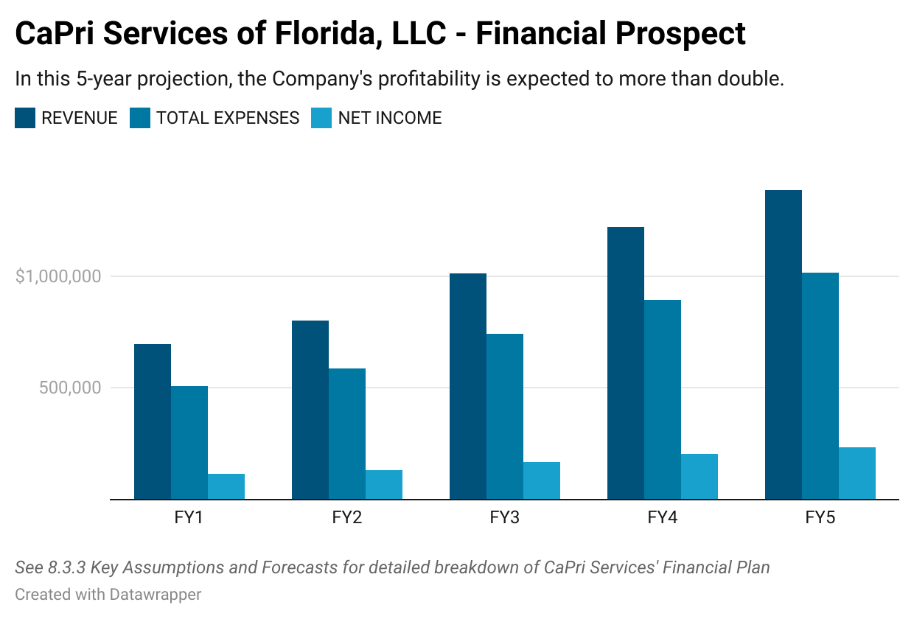

## 8.4 5-year Financial Forecast

|  | **FY1** | **FY2** | **FY3** | **FY4** | **FY5** |
| --- | --- | --- | --- | --- | --- |
| **REMODELING / CONSTRUCTION REVENUE** | $ 695,000.00 | $ 750,000.00 | $ 950,000.00 | $1,150,000.00 | $ 1,300,000.00 |
| **DESIGNER REVENUE** | $ 45,000.00 | $ 52,000.00 | $ 61,000.00 | $ 70,000.00 | $ 85,000.00 |
| **COST MATERIALS** | $ 195,000.00 | $ 225,000.00 | $ 285,000.00 | $ 345,000.00 | $ 390,000.00 |
| **COST LABOR EMPLOYEES** | $ 264,100.00 | $ 304,760.00 | $ 384,180.00 | $ 463,600.00 | $ 526,300.00 |
| **NUMBER OF EMPLOYEES** | 4 | 5 | 6 | 8 | 9 |
| **COST MARKETING / OFFICE** | $ 48,650.00 | $ 56,140.00 | $ 70,770.00 | $ 85,400.00 | $ 96,950.00 |
| **ASSETS** |  |  |  |  |  |
| **CASH** | $ 25,000.00 | $ 98,000.00 | $ 167,000.00 | $ 289,000.00 | $ 430,000.00 |
| **ACCOUNTS RECEIVABLE** | $ - | $ - | $ - | $ - | $ - |
| **INVENTORY** | $ 15,000.00 | $ 25,000.00 | $ 30,000.00 | $ 38,000.00 | $ 50,000.00 |
| **TOTAL CURRENT ASSETS** | $ 40,000.00 | $ 123,000.00 | $ 197,000.00 | $ 327,000.00 | $ 480,000.00 |
| **FIXED ASSETS** | $ 180,000.00 | $ 180,000.00 | $ 180,000.00 | $ 180,000.00 | $ 180,000.00 |
| **DEPRECIATION** | $ 27,000.00 | $ 54,000.00 | $ 81,000.00 | $ 108,000.00 | $ 135,000.00 |
| **NET FIXED ASSETS** | $ 153,000.00 | $ 126,000.00 | $ 99,000.00 | $ 72,000.00 | $ 45,000.00 |
| **TOTAL ASSETS** | $ 193,000.00 | $ 249,000.00 | $ 296,000.00 | $ 399,000.00 | $ 525,000.00 |
| **LIABILITIES & EQUITY** |  |  |  |  |  |
| **DEBT** | $ 197,370.00 | $ 169,738.00 | $ 147,672.00 | $ 118,138.00 | $ 88,603.00 |
| **ACCOUNTS PAYABLE** | $ 8,730.00 | $ 9,166.00 | $ 9,716.00 | $ 10,105.00 | $ 10,509.00 |
| **TOTAL LIABILITIES** | $ 206,100.00 | $ 178,904.00 | $ 157,388.00 | $ 128,243.00 | $ 99,112.00 |
| **SHARE CAPITAL** | $ - | $ - | $ - | $ - | $ - |
| **RETAINED EARNINGS** | $ (13,100.00) | $ 70,096.00 | $ 138,612.00 | $ 270,757.00 | $ 425,888.00 |
| **TOTAL EQUITY** | $ (13,100.00) | $ 70,096.00 | $ 138,612.00 | $ 270,757.00 | $ 425,888.00 |
| **TOTAL LIABILITY & EQUITIES** | $ 193,000.00 | $ 249,000.00 | $ 296,000.00 | $ 399,000.00 | $ 525,000.00 |
| **REVENUE** | $ 695,000.00 | $ 802,000.00 | $ 1,011,000.00 | 1,220,000.00 | $ 1,385,000.00 |
| **TOTAL EXPENSES** | $ 507,754.00 | $ 585,905.00 | $ 739,956.00 | $ 894,008.00 | $ 1,013,259.00 |
| **EBITDA** | $ 187,246.00 | $ 216,095.00 | $ 271,044.00 | $ 325,992.00 | $ 371,741.00 |
| **DEPRECIATION** |  |  |  |  |  |
| **EBIT** | $ 187,246.00 | $ 216,095.00 | $ 271,044.00 | $ 325,992.00 | $ 371,741.00 |
| **INTEREST** | $ 11,448.00 | $ 11,448.00 | $ 11,448.00 | $ 11,448.00 | $ 11,448.00 |
| **PRE TAX INCOME** | $ 175,798.00 | $ 204,647.00 | $ 259,596.00 | $ 314,544.00 | $ 360,293.00 |
| **INCOME TAX EXPENSE** | $ 61,529.30 | $ 71,626.45 | $ 90,858.60 | $ 110,090.40 | $ 126,102.55 |
| **NET INCOME** | $ 114,268.70 | $ 133,020.55 | $ 168,737.40 | $ 204,453.60 | $ 234,190.45 |